2018
Sun | Mon | Tue | Wed | Thu | Fri | Sat
 |  | 1 | 2  Track @ Regionals (MVTHS) 9:00 | 3  Sports Physicals during the day | 4  6th Grade to RLC Earth Day | 5  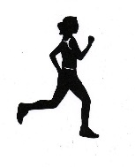
6 | 7  4th&5th to Tri-County Electric  Track @ S’ville PeeWee (RLC) 4:00 | 8  1st,3rd&4th to Mitchell Museum | 9  Track @ W’lawn Co-ed (MVTHS) 11:00  TEACHER APPRECIATION WEEK  Kindergarten Park Day | 10  Track @ S’ville Meet (RLC) 11:00  8th grade graduation breakfast @ Woodlawn Baptist | 11  PTO Fun Day! | 12  Track @ State (Herrin HS) TBA
13 | 14 | 15  Honors Club to Oil Belt  Awards Night 6:00 | 16 | 17  Kindergarten Graduation 8:45 am  Board Meeting 6:00 | 18  PreK Graduation 10:00  Cheer to Kings Island  Woodlawn High Graduation 7:00 | 19
20 | 21  3rd to Mrs. Page’s  4th to Science Center  7th grade field trip  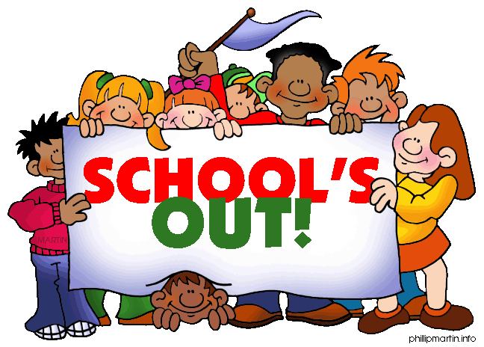  8th to Holiday World | 22  8th grade graduation practice 8:30-10:00  1st to Herzing Farm  8th grade Graduation 7:00 | 23  2:10 Dismissal  8th grade meet at 3:15 for Skyzone Trip | 24  Noon Dismissal  6TH & 7TH bowling field trip | 25 | 26
27 | 28 | 29 | 30 | 31 | REGISTRATION FOR THE 2018-2019 SCHOOL YEAR WILL BE JULY 26  12:00-6:00 PM /  OR YOU MAY REGISTER ONLINE THROUGH TEACHEREASE STARTING  JULY 1  FIRST DAY OF SCHOOL FOR STUDENTS AUGUST 14TH (3:00 DISMISSAL)

